## 接口

### 创建订单

url ：<http://order.taotao.com/order/create>

POST：

{

"payment": 5288,

"postFee": 0,

"userId": "3",

"buyerMessage": null,

"buyerNick": "zhang123",

"orderItems": [

{

"itemId": "9",

"num": 1,

"title": "苹果（Apple）iPhone 6 (A1586) 16GB 金色 移动联通电信4G手机3",

"price": 5288,

"totalFee": 5288,

"picPath": "http://image.taotao.com/images/2015/03/06/2015030610045320609720.jpg"

}

],

"orderShipping": {

"receiverName": "张志君",

"receiverPhone": "",

"receiverMobile": "15800000000",

"receiverState": "上海",

"receiverCity": "上海",

"receiverDistrict": "闵行区",

"receiverAddress": "三鲁公路3279号 明浦广场 3号楼 205室",

"receiverZip": "200000"

}

}

响应：

{

status: 200

msg: "OK"

data: "31431919252344" //订单号

ok: true

}

### 根据订单ID查询订单

url：<http://order.taotao.com/order/query/31414485440695>

GET

响应：

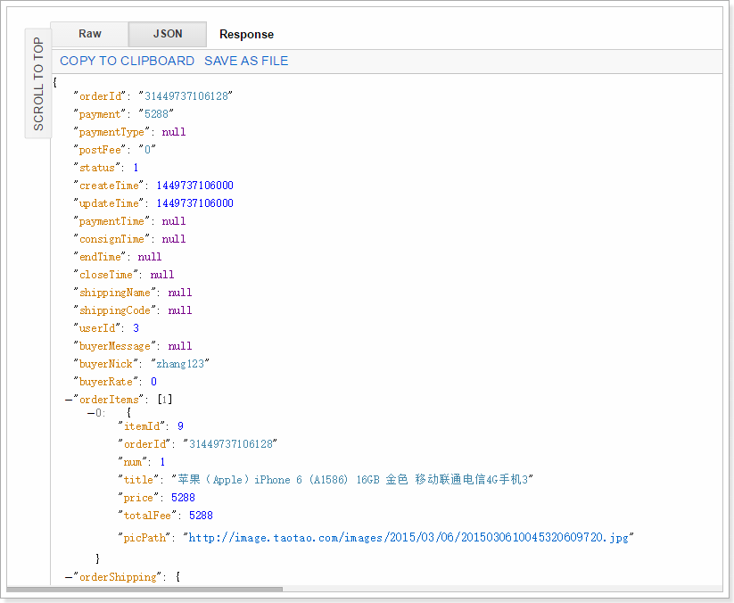

### 根据用户名分页查询订单

url：<http://order.taotao.com/order/query/zhang123/1/5>

参数：/query/{buyerNick}/{page}/{count}

### 修改订单状态

url：<http://order.taotao.com/order/changeOrderStatus>

POST：（更改付款状态、时间）

{

"orderId": "31414485440695",

"status": 2,

"paymentTime": "1414489420444"

}